BENEFIT RAFFLE
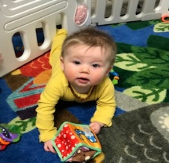

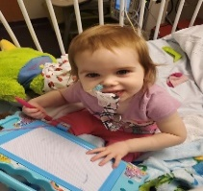

2-YEAR-OLD SARAH ROBERTS DIAGNOSED
WITH STOMACH CANCER
BABY MCLAREN SPEED LOST DADDY TO COVID

BABY HUDSON CRUNKLETON SEVERE HEALTH ISSUES
TICKETS $25.00 EACH
DRAWING ON MAY 27, 2022
FOUNDATION ACADEMY, 120 COMMERCE PKWY, CORNELIA GA
ONE WINNER TAKES ALL
AWESOME PRIZES
YETI COOLER & UTILITY CART FILLED WITH TONS OF GIFT CARDS, GOODIES & GIFT BASKET’S.
A SPECIAL THANK YOU TO OUR COMMUNITY SPONSORS.
CHICK-FIL-A BIGG DADDY’S LINDSEY NASH @ NASH & CO. WICKED CANDLE CO.
ERIN LONDON BLUE WILLOW FLORAL & GIFT’S AURORA FALLS
LAURA & JOSH ANDERSON MIDTOWN GRILL ERWIN RUSH
THE COMFY CORNER SUGARTOPIA ACE HARDWARE INITIALS INC.
THE GATHERING BOX CASSIE CHEEK @ SALON 447 TIMS PHARMACY
BROWNIES BY FAITH FARM & LAVISH CHICAGO PIZZA EL PATRON
BOB & TEDS TROPHY SHOP CANDY RAY DILL @ NASH & CO CREATIVE EDGE DESIGNS, LLC
SCRAP SCAVEY DESIGNS JACOB DARLING @ UNICOI OUTFITTERS ALL ABOUT MONROE
CANDACE NEWSOM @ ELEVATED HAIR LOUNGE
SEVERAL ANONYMOUS COMMUNITY SPONSORS

