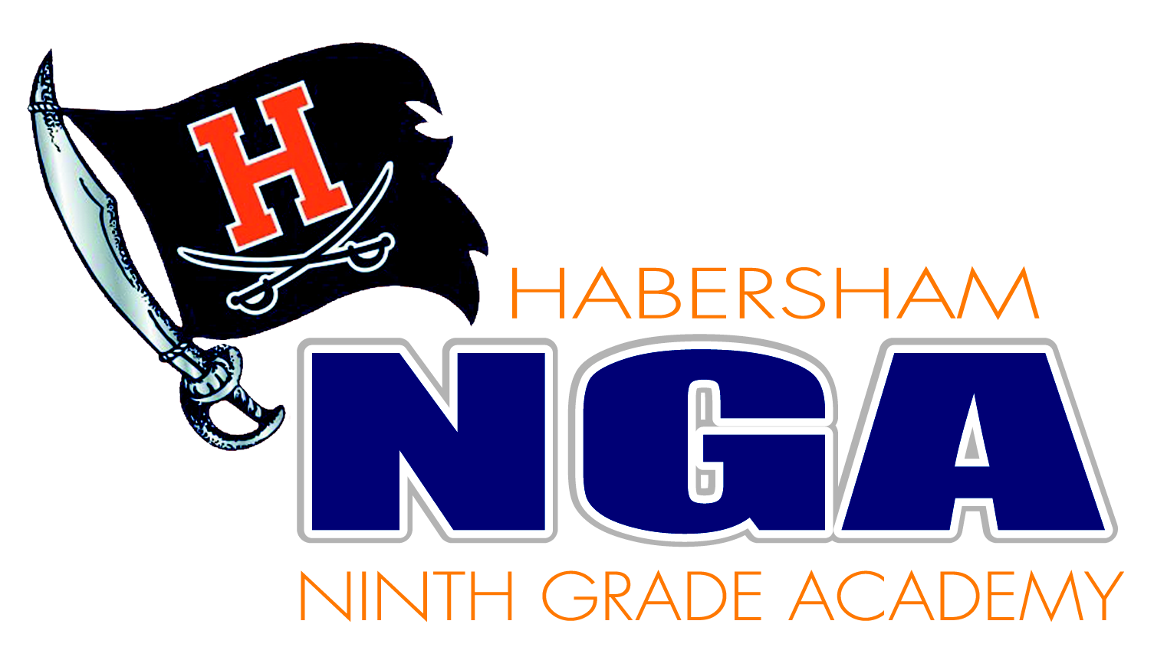

September 7, 2021
News Release

Contact Person: Dr. Connie Franklin, Principal
(706) 778-0830

This morning, the HNGA administration was notified by the guardian of one of our students that a concerning post was made to Snapchat. The post was a picture of one of our students holding a BB gun and was posted to Snapchat by another student with what could be interpreted as a threatening message. This was immediately investigated by school administration and the Habersham County Sheriff’s Office and found to be an inappropriate joke and not a viable threat against our students, staff or anyone else. The student in the picture was interviewed and it was determined that he made no threats and posed no danger to anyone. Even though it was only intended as a joke, both law enforcement and school officials are dealing with the student who actually made the post.

Parents and guardians of HNGA students were made aware of the situation through a OneCall message. In addition, students were also made aware of the situation, as well as the seriousness of posting inappropriate messages to social media and the dangers that could be involved in the sharing of one’s personal pictures. As always, parents were encouraged to contact the school if they have any questions or concerns. Students may also report an incident through the Raider Report app, an anonymous, free app used to report safety concerns directly to administration.

